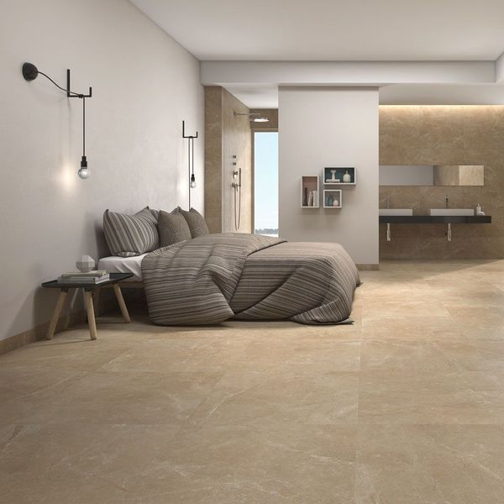**Pecan Brown Polished 59x59 Tiles:**

## **Product Description**

If your interior spaces are looking a little dated, refresh them by introducing the natural look! These Pecan Brown Polished 59x59 Tiles have a stunning marble effect design. Marble is one of the most sought after natural stone types, but it's expensive and requires treatment and maintenance, so these realistic porcelain floor tiles are a fabulous alternative! They have a brown hue and a shimmering polished finish. Order yourself a sample tile.

To prevent staining, we highly recommend sealing these tiles with [LTP MPG sealer](https://www.wallsandfloors.co.uk/ltp-cleaning-protecting-ltp-mpg-tile-sealer-11270), both before and after grouting. This can be applied as per the manufacturer’s instructions using a [LTP Buffing Cloth](https://www.wallsandfloors.co.uk/ltp-maintenance-tools-blue-buffing-cloth-2-pack). For everyday cleaning, we only recommend [LTP Waxwash](https://www.wallsandfloors.co.uk/ltp-cleaning-protecting-ltp-waxwash-tile-maintenance). Please refer to this [downloadable maintenance PDF](https://www.wallsandfloors.co.uk/media/catalog/product/polished-porcelain-maintenance-cleaning.pdf).

## **Product Info**

* Product ID: 15589
* Tiles Per SQM: 2.8727377190463
* Sale by: Per SQM
* Size: 590x590x10mm
* Weight: 7.86 KG
* Material Type: Porcelain
* Finish: Polished
* Colour: Brown
* Suitability: Floors
* Grade: 4
* Rectified Edge: Yes
* Underfloor Heating; Yes
* Thickness (mm): 10